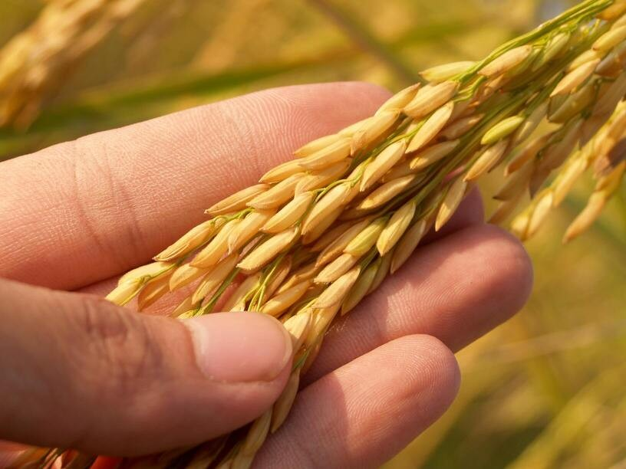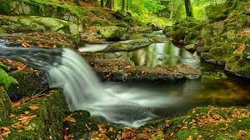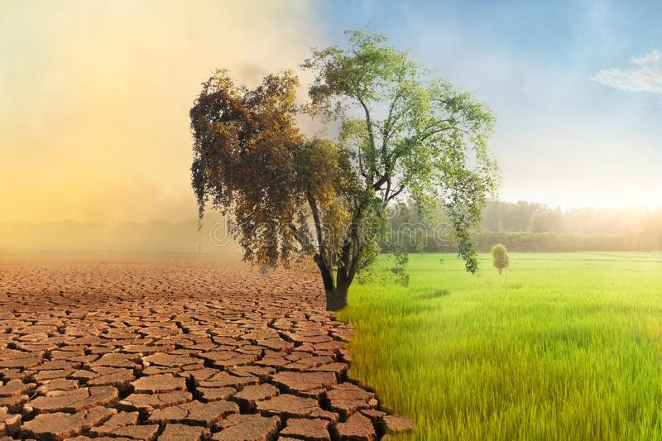

**1**

**Define your problem statement**

What problem are you trying to solve? Frame your problem as a How Might We statement. This will be the focus of your brainstorm.

**5 minutes**

Soil Erosion

Climate change

Lack of mechanization

Irrigation

**Key rules of brainstorming**

To run an smooth and productive session

Stay in topic.

Encourage wild ideas.

Defer judgment.

Listen to others.

Go for volume.

If possible, be visual.

**PROBLEM**

There are some specially able people who are mute and dumb could not able to communicate with other people and find it difficult. To help them communicate an application is built using AI

# 2

**Brainstorm**

## Write down any ideas that come to mind that address your problem statement.

**10 minutes**

RAHUL S

Useof CoverCrops

planting permanent vegetation

Controlof waterflow

**TIP**

You can select a sticky note and hit the pencil [switch to sketch] icon to start drawing!

PRAKSH T

*Reducing Livestock Methane Emissions*

*Increasing Soil Health*

Efficient irrigation management

# 3

**Group ideas**

## Take turns sharing your ideas while clustering similar or related notes as you go. In the last 10 minutes, give each cluster a sentence-like label. If a cluster is bigger than six sticky notes, try and see if you and break it up into smaller sub-groups.

**20 minutes**

# 4

**Prioritize**

## Your team should all be on the same page about what's important moving forward. Place your ideas on this grid to determine which ideas are important and which are feasible.

**20 minutes**

**TIP**

Add customizable tags to sticky notes to make it easier to find, browse, organize, and categorize important ideas as themes within your mural.

# After you collaborate

You can export the mural as an image or pdf to share with members of your company who might find it helpful.

# Quick add-ons

### Share the mural

*keeping Agricultral Green*

*Agriculture robotswillbea perfecttoolof solutionfor labor shortages*

Organic Practices

Contour Farming

*Afforestation topreservesoil*

*Protecting farmland*

*Controlof water flow*

keeping Agriculture Green

Efficient irrigation management

*cloud computing for analyzing and processing the remote data*

Redirect runoff aroundthe erodedland orcapture flow

**Share a view link** to the mural with stakeholders to keep them in the loop about the outcomes of the session.

Pasture- Based Livestock management

### Export the mural

AVarietyof landscaping materials includingcoirfiber biologs,stoneor woodcanbeused tocreate

Riprap, Stabilizingsoil withstones andboulders

*Renewable Energy*

Export a copy of the mural as a PNG or PDF to attach to emails, include in slides, or save in your drive.

Redirect runoff aroundthe erodedland orcapture flow

Control Blanketsand FiberRolls (Temporary)

pushing for Climate- Friendly Policies

*Keeping Agriculture Green*

ALFIN BELAN P

*Irrigation allowsfarmers andgardeners toefficientlyuse waterto guaranteeplant growthc*

*AVarietyof landscaping materials includingcoir fiber biologs,stoneor woodcanbe*

*Cloudservices areessentialto be integrated withIOTto analyzeand processthe remotedata*

*Mechanized formoffarm inputs*

Agriculture robots reduce operation cost and operating time

DHANUSIGA S

*Using5Gbandcan havethepositive impact son agriculturalsector for agricultural operationlikedrone control,realtime monitoring,seeding operationsetc*

*Continuous internet connectivity costcanbe overcomeby usingGSM mudule*

Improves living standard offarmers

*Reduces weed growth*

*Agriculture robots reduce operation cost and operating*

Improves the yield of growth

*Countour farming*

Precisison farming

# Importance

*Croprotation and conservation tillage thathelp improvesoil moisture conservation.*

If each of these tasks could get done without any difficulty or cost, which would have the most positive impact?

*Customhiringof farmequipment resultsin increasedpower availabilityand landproductivity*

*Produce hydroelectric*

*power*

*DevelopingDSS modelcan coordinatefew modelslikelinking cropproduction withexternal sources*

*Irrigationallows farmersand gardenersto efficientlyuse waterto guaranteeplant growth.*

Monitor your Progress

*Check weekly*

*Prevent deforestation andfamine*

*Agriculture robotsreduce operationcost andoperating time*

**TIP**

Participants can use their cursors to point at where sticky notes should go on the grid. The facilitator can confirm the spot by using the laser pointer holding the **H key** on the keyboard.

*usedtocreate*

# Keep moving forward

### Strategy blueprint

Define the components of a new idea or strategy.

### [Open the template](https://app.mural.co/template/e95f612a-f72a-4772-bc48-545aaa04e0c9/984865a6-0a96-4472-a48d-47639307b3ca)

Customhiringof farmequipment resultsin increasedpower availabilityand landproductivity

**Customer experience journey map**

Understand customer needs, motivations, and obstacles for an experience.

### [Open the template](https://app.mural.co/template/b7114010-3a67-4d63-a51d-6f2cedc9633f/c1b465ab-57af-4624-8faf-ebb312edc0eb)

**Strengths, weaknesses, opportunities & threats**

Identify strengths, weaknesses, opportunities, and threats (SWOT) to develop a plan.

|  |  |
| --- | --- |
|  |  |
|  |  |

### [Open the template](https://app.mural.co/template/6a062671-89ee-4b76-9409-2603d8b098be/ca270343-1d54-4952-9d8c-fbc303ffd0f2)

[**Share template feedback**](https://muralco.typeform.com/to/CiqaHVat?typeform-source=app.mural.co)

Goodfor rainfall area

Preserves soil nutrients

*Agriculture robotswillbea perfecttoolof solutionfor labor shortages*

*precision farming techniques*

Improves theyieldof growth

*pushingfor Climate- Friendly Policies*

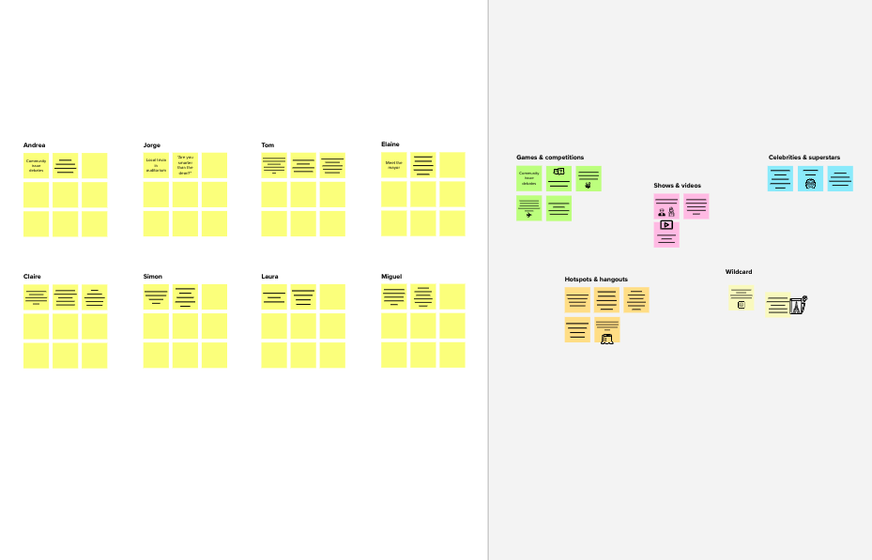

|  |  |  |
| --- | --- | --- |
| **Template** | **Brainstorm**  **& idea prioritization**  Use this template in your own brainstorming sessions so your team can unleash their imagination and start shaping concepts even if you're not sitting in the same room.  **10 minutes** to prepare  **1 hour** to collaborate  **2-8 people** recommended  [**Share template feedback**](https://muralco.typeform.com/to/CiqaHVat?typeform-source=app.mural.co) | **Before you collaborate**  A little bit of preparation goes a long way with this session. Here’s what you need to do to get going.  **10 minutes**   1. **Team gathering**   Define who should participate in the session and send an invite. Share relevant information or pre-work ahead.   1. **Set the goal**   Think about the problem you'll be focusing on solving in the brainstorming session.   1. **Learn how to use the facilitation tools**   Use the Facilitation Superpowers to run a happy and productive session.  [**Open article**](https://support.mural.co/en/articles/2113740-facilitation-superpowers) |
|  | **Need some inspiration?**  See a finished version of this template to kickstart your work.  [**Open example**](https://app.mural.co/template/e5a93b7b-49f2-48c9-afd7-a635d860eba6/93f1b98d-b2d2-4695-8e85-7e9c0d2fd9b9) |  |

# Feasibility

#### Regardless of their importance, which tasks are more feasible than others? (Cost, time, effort, complexity, etc.)

|  |  |  |  |  |
| --- | --- | --- | --- | --- |
|  |  |  |  |  |
|  |  |  |  |  |